# Scanning Gradient Fourier Transform V0.2.21 (2/23/2020)

**Quick-Start Manual**

Max Salick, Brett Napiwocki, Rachel Kruepke, Randolph Ashton, Wendy Crone

University of Wisconsin - Madison



Thank you for downloading the SGFT program for MATLAB! The Scanning Gradient Fourier Transform (SGFT) program allows for quantification of striated patterns, such as those formed by sarcomere structures in myocytes. The software has been designed to automatically determine striation direction and uniformity in 2D images. Exported data includes direction histograms and an Excel file with the analyzed pattern strengths, alignments, and wavelengths, as well as parameters and a summary of the image’s patterning. The complete, analyzed dataset is also output as a MATLAB data file.

A few things to note:

* This program requires both MATLAB and the MATLAB Image Analysis Toolbox to run. MATLAB must be version R2016b or newer.
* Since this code involves a large number of Fourier transforms to determine pattern strength, it can be computationally demanding. A modern desktop or laptop computer can handle most standard (~2000 X 2000) images; however, a faster computer or cluster may be recommended for large datasets. Reducing the SCANRESOLUTION will also speed up analysis, at the cost of output resolution.

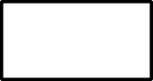

**Start**

**Locate**

**Image**

**Data Summarization and**

**Reporting**

**Set SCALE PATTERNSIZE and SCANRES**

**Import Image and**

**Normalize**

**SGFT Loop**

**Set BLOCKSIZE**

**Coverage Scan**

**Apply Local Contrast**

**Filter (Gaussian Blur)**

* Since several *in vitro* myocyte models have unaligned cells, the code does not depend on any prior assumption of directionality; however, outputs such as ‘lanewidth’ do assume vertical orientation of any lanes for micropattern-based myocyte models.





***Input Phase***

Figure 1: Algorithm flowchart describing the steps implemented in the SGFT program.



***Analysis Phase***

Getting Started

* 1. Unzip all files into the same directory. Note that all images must be in .TIF format and have the scalebar removed.
  2. Open MATLAB and open the “sft_main_v026.m” file. This is the main calling function for the program.
  3. In the command window, type the following line:

[results] = sft_main_v026(inputpath,inputfiles,scale,patternsize,scanresolution)

where ‘inputpath’, ’inputfiles’, ’scale’, ’patternsize’, and ‘scanresolution’ are inputs determined by the user. Each of these inputs is described in further detail below:

**inputpath**

name of the directory containing image files

Ex: ‘folder’

**inputfiles**

name of the file to be analyzed

Ex: ‘image’

**scale**

scale of the image in microns per pixel (μm/pix)

Ex: 0.21 (suggested scale for image at 60x magnification with a resolution of 4096x4906 pixels)

Ex: 0.03 (suggested scale for image at 100x magnification with a resolution of 4096x4906 pixels)

**patternsize**

approximate estimation of patternsize in microns (μm). The size of each wavelength must be estimated in order to optimize the size of the scanning window. A ballpark estimate (within 60%-140% of actual size) will suffice.

Ex: 1.9 (in the case of sarcomere striation, the standard length in relaxed human heart tissue is ~1.9 microns)

**scanresolution**

number of pixels to skip between analysis scan. For the most detailed analysis, a scanning resolution of “1” be used (but this is not recommended). At first, multiple values may be attempted, depending on the image size, number of images, computation speed, and time available for analysis. Once the analysis begins, you will get time predictions that will help you determine whether this value was properly set. If using a scanresolution greater than 1, it must be an even integer.

Ex: 16

* 1. The code will now scan through the image, quantifying the pattern. The edge of the image will be removed to reduce computation time, where the size of the area removed is determined by the given parameters.
  2. Once completed, the data will be exported as an .xls file and .mat file, each containing the calculated pattern values for each scanned X and Y position, as well as parameters and data summaries for the analysis run. Four .png files of pattern alignment histograms are also produced with a .csv file of its data. These files will be placed in the same folder as the original image file.

The user may also explore the analyzed data contained in the **results** variable, which contains **results.params, results.summary, results.plots**. The following is a description of each cell:

|  |  |
| --- | --- |
| results.data | A large data matrix, with each row containing the analysis results for each individual scan. Each column represents the following, in this order:   1. X coordinate 2. Y coordinate 3. distance-from-edge(um) 4. pattern direction 5. pattern wavelength 6. specimen width   *Note: this data is all contained in the ‘data’ page in the exported*  *excel file* |
| results.params.filename | Original image file name |
| results.params.pathname | Folder location for original image |
| results.params.umperpix | Microns-per-pixel conversion |
| results.params.scanjump | Number of pixels jumped between individual scans |
| results.params.blocksize | Size of the subset matrix used for each individual scan |
| results.summary.superiorang | The angle that the most high-strength patterns are pointed  Toward (measured CCW from positive x axis) |
| results.summary.sarcarea | Percentage of the image that contains patterns that meet a  set strength threshold; note that if there are no cells present  in a region of an image it will contribute to this calculation,  thus resulting in a lower value. |
| results.summary.sl_ave | Average pattern strength |
| results.summary.sl_std | Standard deviation of pattern strength |
| results.summary.p20 | Percentage of detected patterns that are within 20 degrees  of the superior angle (higher value indicates uniform directionality) |
| results.summary.p15 | Percentage of detected patterns that are within 15 degrees of the superior angle (higher value indicates uniform  directionality) |
| results.summary.p10 | Percentage of detected patterns that are within 10 degrees  of the superior angle (higher value indicates uniform directionality) |
| results.plots.im | Sample image |
| results.plots.str | Pattern strength matrix |
| results.plots.dir | Pattern direction matrix |
| results.plots.quiv | Pattern direction quiver plot |
| results.plots.sl | Pattern wavelength matrix |
| results.plots.align | Weighted histogram of pattern directions |

Figure Outputs

This code outputs 7 figures for each image processed. Histograms 1, 2, and 5 plot direction data measuring counterclockwise from the horizontal (positive x) axis. Histograms 3,4, and 6 add 90˚ and plot direction data measuring counterclockwise from the vertical (positive y) axis. The seventh figure is a visual representation of these reference axes. Only histograms 1-6 are saved for each run of the software.

These figures present the same direction data measuring from different reference axes to give the user the ability to choose the best way to visualize the data for each image. The sorted data for each histogram is also output as a .csv file for the user to further work with. Consider the following 4 example images and the different ways the direction histograms represent the direction data.



**B)**

**A)**

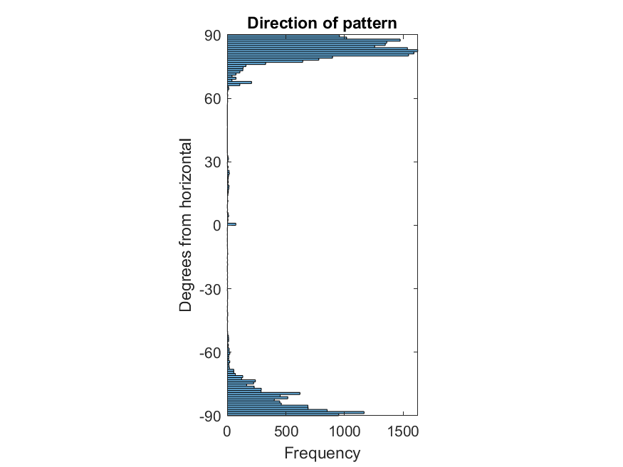

**D)**

**C)**

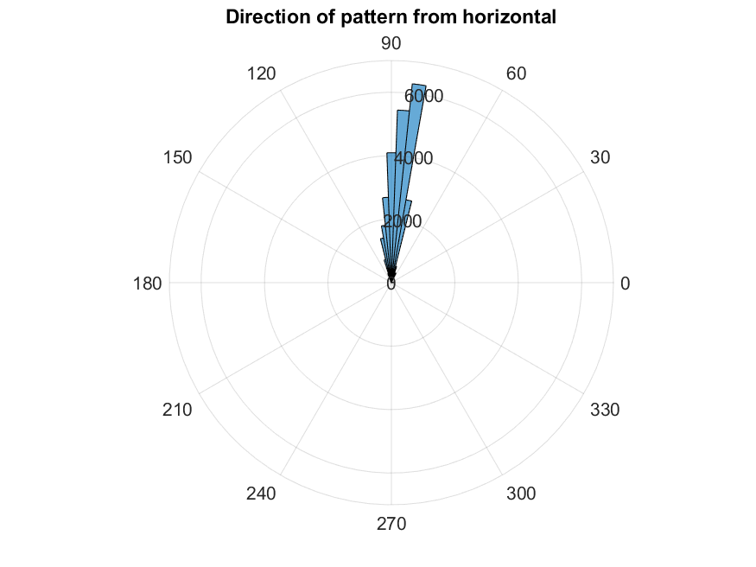

Figure 2: HLA4 NcadAlphaA 100x_4hrss (courtesy of Brett Napiwocki, Crone lab) in 2A shows a vertically aligned pattern of myofibrils. For this type of pattern, direction data should be measured from the horizontal axis and is best visualized in SGFT Histograms 1 ,2, and 5.

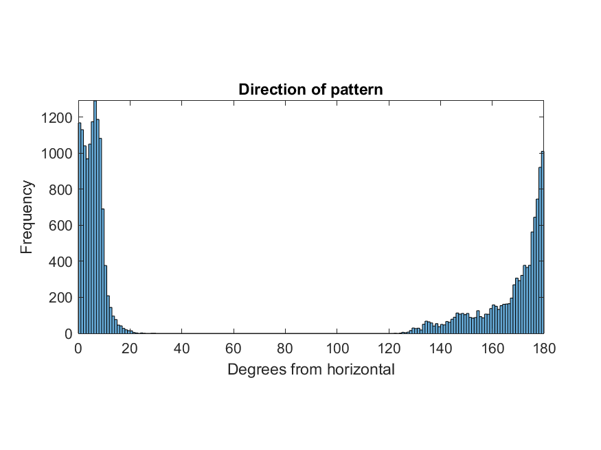

**B)**

**A)**

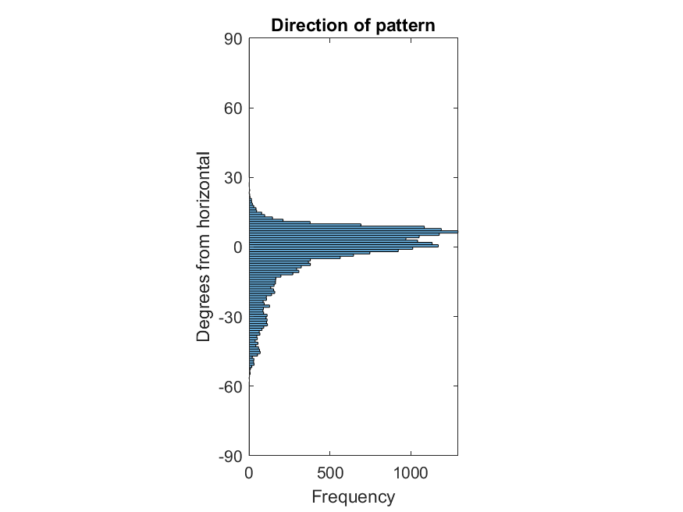

**D)**

**C)**

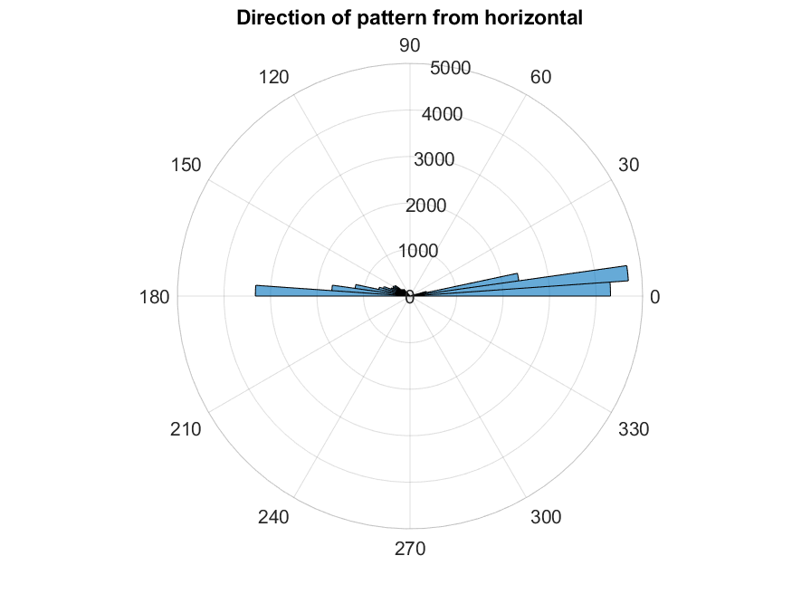

Figure 3: UW2020P19 Pat 2Hz 100x_2hr (courtesy of Brett Napiwocki, Crone lab) in 3A shows a horizontally aligned pattern of myofibrils. For this type of pattern, direction data should be measured from the horizontal axis and is best visualized in SGFT Histograms 1, 2, and 5.

**A)**

**B)**

**D)**

**C)**

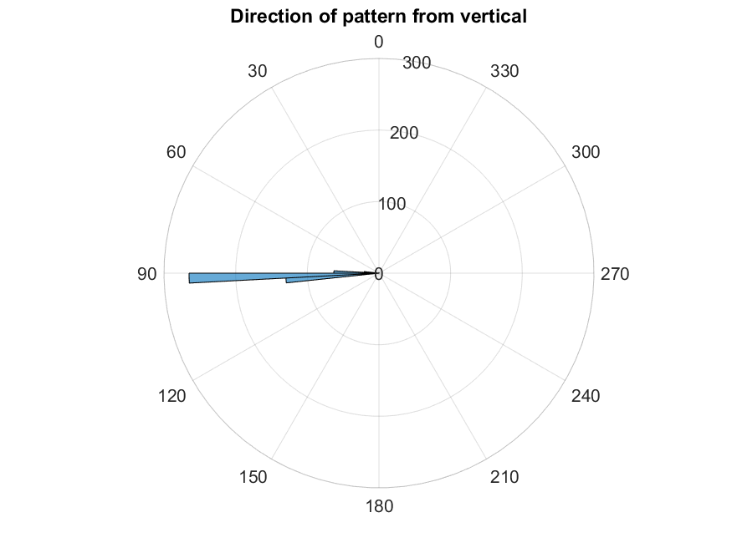

Figure 4: CFPat9 D2 Decell 20xhr_1b (courtesy of Brett Napiwocki, Crone lab) in 4A shows a horizontally aligned pattern of fibronectin. For this type of pattern, direction data should be measured from the vertical axis (add 90˚) and is best visualized in SGFT Histograms 3, 4, and 6.

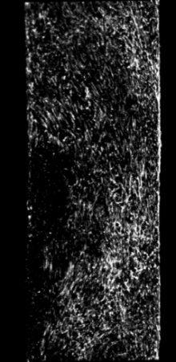

**A)**

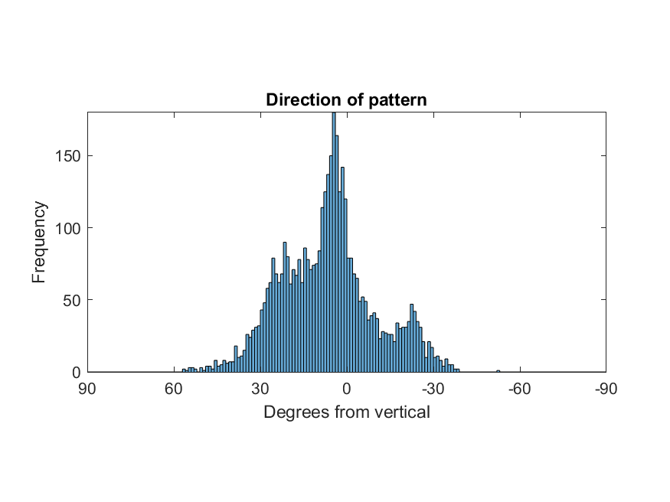

**B)**

**C)**

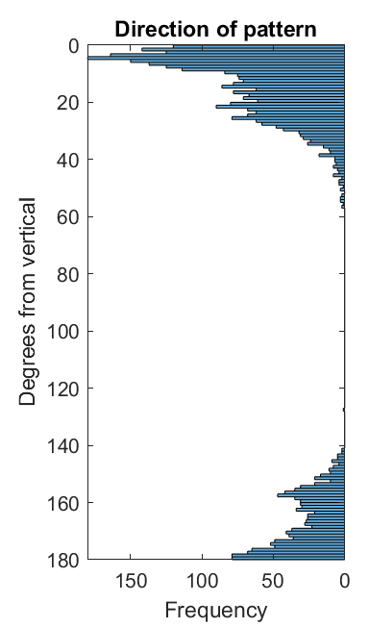

**D)**

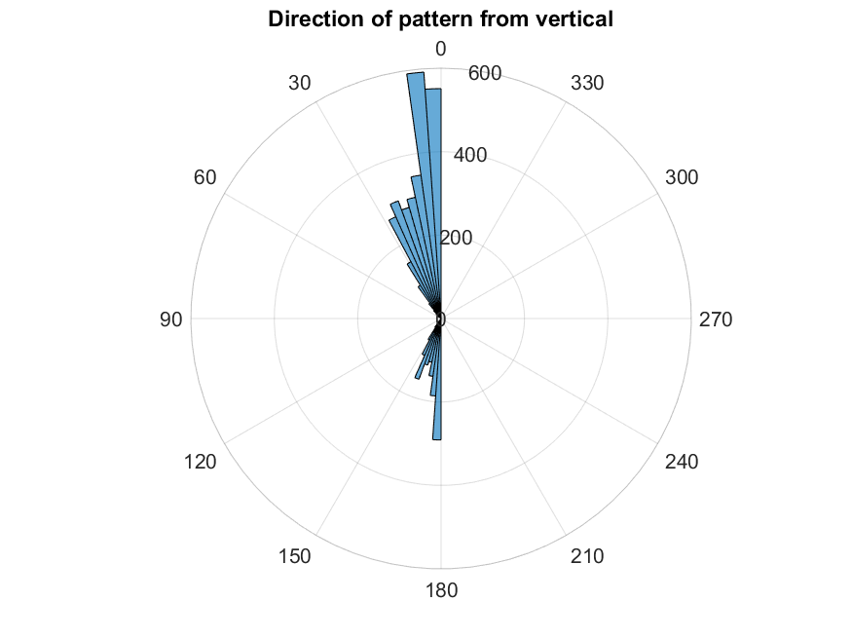

Figure 5: CFPat9 D2 Decell 20xhr_4a (courtesy of Brett Napiwocki, Crone lab) in 5A shows a vertically aligned pattern of fibronectin. For this type of pattern, direction data should be measured from the vertical axis (add 90˚) and is best visualized in SGFT Histograms 3, 4, and 6.

Figure 6 shows a visual representation of these reference axes used for the direction plots. This output is displayed for each run but is not saved.

Figure 6: Reference axes used for direction histograms

Intermediate Steps in Analysis

To further examine how this software works, consider again the image shown in Figure 2A.

Figure 2A: HLA4 NcadAlphaA 100x_4hrss (courtesy of Brett Napiwocki, Crone lab)

This image was taken with 100x magnification. The following parameters are used for the inputs:

scale = 0.03 μm/pix

patternsize = 2 μm

scanresolution = 16

The following images show some intermediate steps within the SGFT software. If the user desires to see these intermediate images, they can add a breakpoint after the line where the array is produced and use the MATLAB command ‘imshow’ to show the figure.

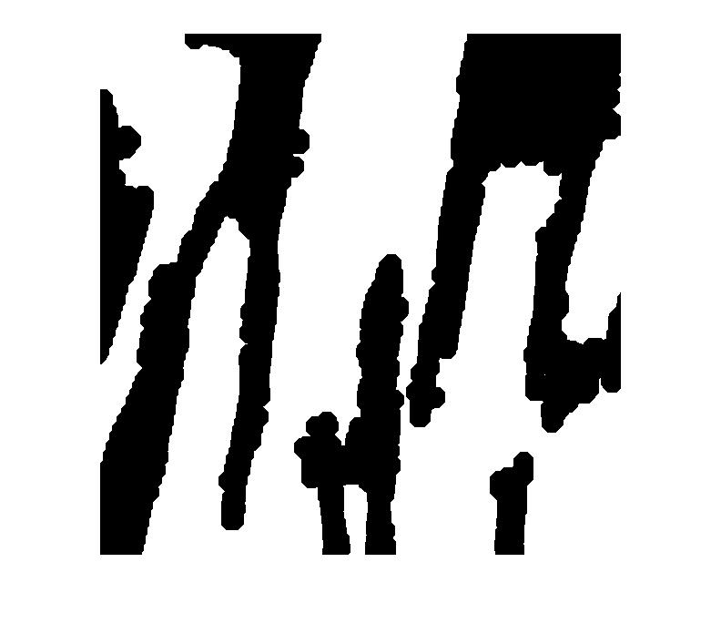The parameters ‘patternsize’ and ‘scale’ contribute to the development of m_cov. This array indicates the areas of interest of the image that will later be scanned, with 1s indicating areas of adequate signal (white) and 0s indicating areas that will be skipped the reduce computation time (black). m_cov for this example is shown in Figure 7.

Figure 7: plot of m_cov array, where white indicates the area of interest that will later be scanned.

Two other important intermediate arrays include m_str and m_dir, which show the calculated strength and direction of the pattern, respectively. These arrays are plotted in Figures 8 and 9. While the results of the analysis are more useful numerically in the output files, these images show the extent of the detail in the scanning process. This can be adjusted in the ‘scanresolution’ input, which will be discussed in further detail in the following section.

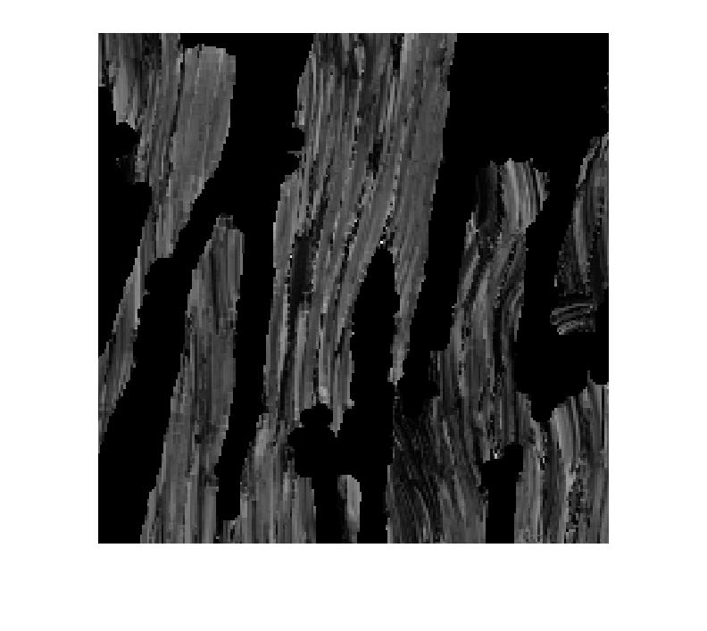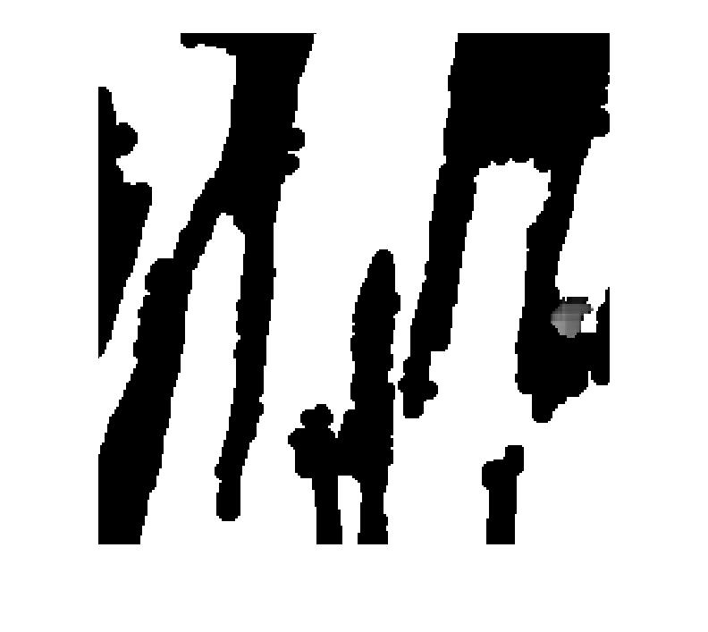

Figure 8: plot of m_str array, with values of the calculated strength of the pattern.

Figure 9: plot of m_dir array, with values of the calculated direction of the pattern.

Varying inputs

The inputs ‘patternsize’ and ‘scanresolution’ may be varied during analysis to ensure a more accurate analysis for each image. Increasing ‘patternsize’ increases the area in m_cov, which will result in scanning for more area of the image but also an increased computation time. Decreasing ‘patternsize’ will dramatically reduce computation time but may cut important areas out of the scanned region. Examples of m_cov with varying ‘patternsize’ are shown in Figures 10 and 11.

Figure 11: m_cov with low ‘patternsize’ (1)

Figure 10: m_cov with high ‘patternsize’ (4)

Decreasing ‘scanresolution’ will lower the number of pixels skipped between each analysis scan. This will result in a more accurate analysis but much longer computation time. Similarly, increasing ‘scanresolution’ will result in a faster computation but decrease the accuracy of the scan. Examples of m_str and m_dir with a higher ‘scanresolution’, and therefore lower accuracy, are shown in Figures 12 and 13.

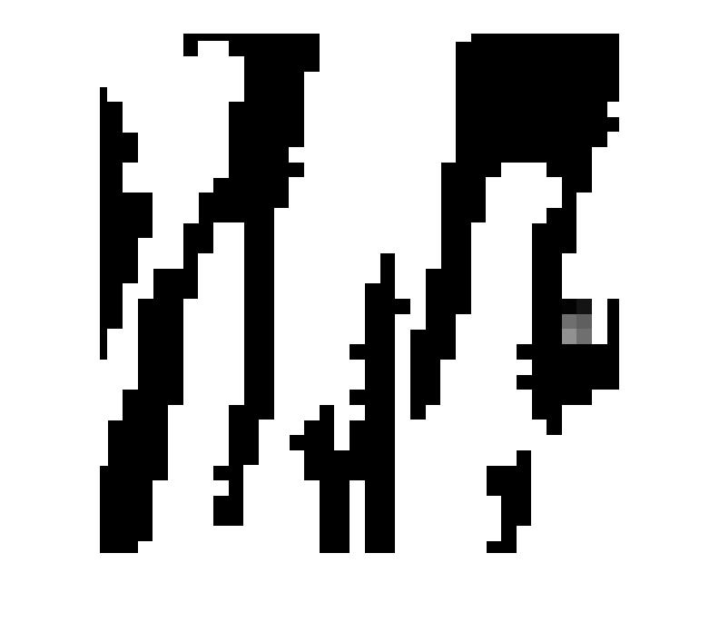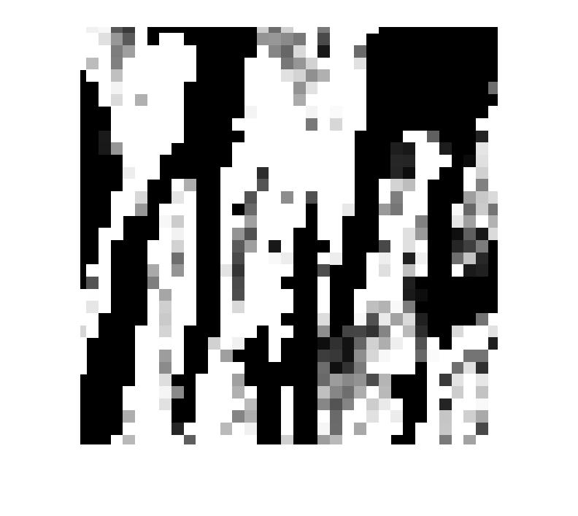

Figure 12: m_str with high ‘scanresolution’ (100)

Figure 13: m_dir with high ‘scanresolution’ (100)

Different Magnification

The ‘scale’ of an image is a fixed parameter that should only be changed when changing the magnification of the image. While this software is originally written to process images at 100x magnification, it may be applied to other images if the scale is adjusted accordingly. The image in Figure 14, for example, is taken at 60x magnification. It can be successfully analyzed with this software if the ‘scale’ is increased from to 0.21 μm/pix. When changing scale however, the user is strongly encouraged to vary patternsize and scanresolution as well to ensure a thorough and accurate scan.

Figure 14: CMCF12 0CF 8b Day18 60x_5 aa (courtesy of Brett Napiwocki, Crone lab)

Thank you for using this software, and good luck on all of your pattern analyses! For questions and feedback, please contact [**maxsalick@gmail.com**.](mailto:maxsalick@gmail.com)